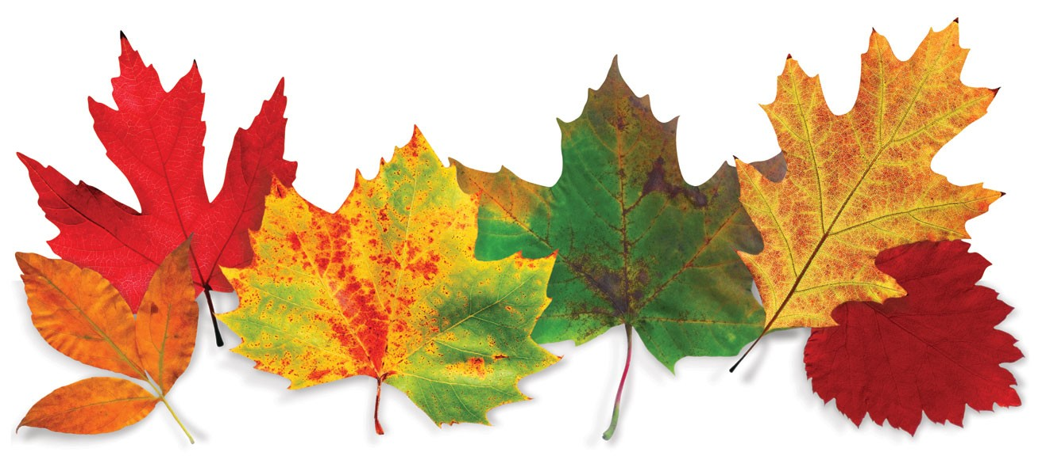
The Salvation Army, Nanaimo Ministries
505 8th Street
Fall Fair

Sunday, September 15
1:00 pm to 4:00 pm
Free Food, Games, Music and Fun

